**CV Format** 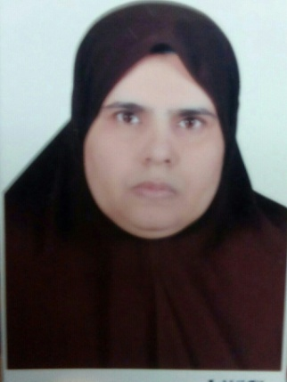

|  |  |  |  |  |
| --- | --- | --- | --- | --- |
| **1. Basic Information** | | | | |
| ايمان ابو الحمد احمد | | | Eman Abo Elhamd Ahmad | |
| Date of Birth: 1-6-1965 | |  | | |
| National ID | |  | | |
| Last University Degree  Prof.of Radiodiagnosis | | Faculty of Medicine,Assiut University, Egypt | | Graduation Date  MBB CH, 1989  MSc(Radiodiagnosis),1994  MD (Radiodiagnosis),2001  Assisstant prof.2006  Prof.of Radiodiagnosis,2013 |
| Title: | | Field of specialization:Carotid Doppler flow Imaging  Woman Imaging(breast sonography) | | |
| Affiliation: | |  | | |
| Current Position: | |  | | |
| Contact Information:  Mobile Phone: 01001980793 Fax: E-mail dr.eman_08@yahoo.com | | | | |
| Last three recent relevant publications  *Authors (underline your name), year, title, Journal, vol. and pages* | | | | |
| 1 | Attendance and active participation of ESWIH Breast Imaging workshop on 16-17 December 2006 at New kasr El Einy Teaching Hospital  Certificate of attendance of : ESWIH Breast Imaging workshop on 12-14 June,2008  Attendance and active participation of ESWIH Breast Imaging workshop and conference:Breast Imaging Update2014 on 12-13 November,2014 | | | |
| 2 | Supervising MSc:  Recent Advances in breast cancer imaging 26-1-2010 to 18-7-2011 | | | |
| 3 | Current supervision ofMSc:  Value of MRI Perfusion in Descrimination between Benign and Malignant Breast Masses. | | | |
|  | | | | |



1-The value of lipoprotein(A), Homocysteine, and Doppler of Carotid and femoral arteries in assessment of Atherosclerosis in asymptomatic cardiovascular risk factors

2-Role of Magnetic resonance imaging in the evaluation of exophthalmos

3-Magnetic Resonance Imaging Findings of two sellar lesions:Pituitary adenoma and craniopharyngioma.

4-Role of Multidetector CT in diagnosis of acute pulmonary embolism

5-Assessment of Biocorrelates for brain involvement in female patients with Rheumatoid Arthritis

6-Multidetector Computed Tomography of Diaphragm:Anatomic variants and diagnostic problems in adult population.

7-Impact of intrauterine growth restriction on neonatal frontal lobe dimensions (Transcranial sonographic measurrments)

8-Multidetector Computed Tomography evaluation in neonatal respiratory distress:clinical implication